14.22: The buoyant force is

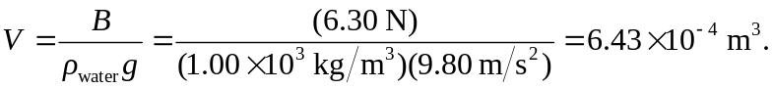

The density is

